Asset store: https://u3d.as/2GpD
If you have any suggestions or questions, you can write to this email: pirate.parrot.software@gmail.com

How to use Humanoid animation?
- Find the animation you need on the website https://www.mixamo.com and download it with the following settings:
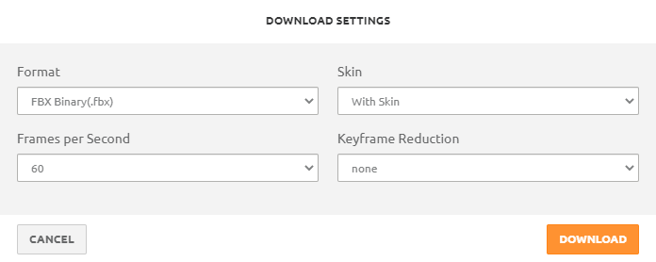
- Import the animation into your Unity project.
- Select animation in Unity. In the Inspector window, on the Rig tab, change the Animation Type to Humanoid. Apply.
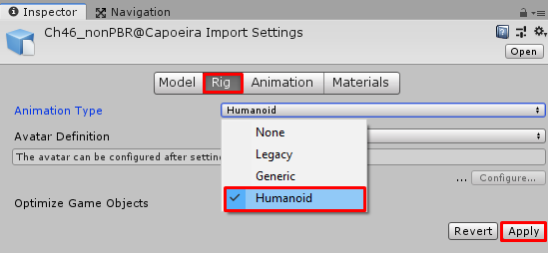
- Make sure your model is also set to Humanoid Animation Type:
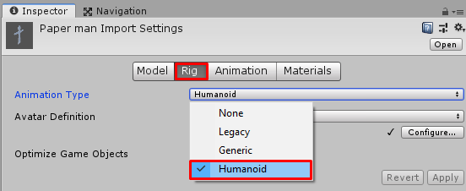

List of animations used in the Video
Dance:
Hokey Pokey
Rumba Dancing
Salsa Dancing

Idle:
Arm Stretching
Idle
Shaking Hands 2

Running:
Goofy Running
Running
Running Forward Flip

